AI-Assisted Documentation for Home Health and Hospice Nurses

UCI - UET Collaboration

Table of Content
- Introduction 4
  - Problem Statement 4
  - NurseChart 4
- Methodology 5
  - Speech To Text 5
  - Google Generative AI 5
  - Double Check 6
  - Download Template 6
  - Saved to Database 6
- Flow Of NurseChart 7
- Development steps 8
  - Handling Start and Stop Recording 8
  - Voice To Text 8
  - Prompts for information extraction 10
  - Call to Google’s Generative Model 11
  - Save template to database 11
  - Populating Modal’s response to document 12
  - Pre-load the templates list 13
- Technology Used 14
  - Frontend 14
  - Backend 15
  - Third Party Integration 15
- Tools Used 15
  - GitHub 15
- Run NurseChart locally 16
  - Prerequisites 16
  - Clone the Repository 16
  - Run the Client Side 16
    - Install Dependencies 17
    - Configuration 17
    - Running the Application 17
  - Run the backend side 17
    - Install Dependencies 17
    - Configuration 18
    - Running the Application 18
- Conclusion 18

Table Of Figures
- Figure 1. Methodology diagram
- Figure 2. Flow Diagram of NurseChart
- Figure 3. Tools Used GitHub

Introduction

Problem Statement
Home health and hospice nurses often struggle with the immense burden of documentation requirements. The charting process alone can take at least an hour and a half to complete, making it a time-consuming task that adds significant pressure to their already demanding roles. This lengthy process not only takes away valuable time that could be spent caring for patients but also adds to the overall workload, making it difficult for nurses to manage their time efficiently.

Moreover, the reliance on manual paperwork heightens the risk of errors or incomplete records, which can have serious consequences for patient care. Reducing the time required for charting would greatly benefit nurses by easing their workload and allowing them to focus more on patient care. Simplifying this process could also lead to more accurate documentation, ultimately improving the quality of care provided.

NurseChart
To address these challenges, I have implemented two key features in this project:
- An AI system capable of recording and transcribing nurse-patient interactions during home visits, generating real-time documentation,
- And AI-driven templates that can automatically populate relevant patient information based on the context.
- For the Vital Signs template, the system extracts information like the patient’s Temperature, Pulse, Respiration, Blood Pressure, Oxygen Saturation, Pain Level, and Blood Sugar Level. Each of these vital signs is essential for monitoring the patient's current health status and identifying any urgent medical needs.
- For the Head-to-Toe Assessment, the system guides healthcare providers through a comprehensive evaluation of the patient’s overall condition:
  - General Appearance: The system prompts the provider to describe the patient's general appearance, including posture, grooming, and any signs of distress.
  - Skin: The system assists in assessing skin color, temperature, moisture, and the presence of any lesions or abnormalities.
  - Head and Neck: The system directs the examination of the head, eyes, ears, nose, throat, and neck for any abnormalities.
  - Chest and Lungs: The system aids in assessing respiratory effort, breath sounds, and signs of respiratory distress.
  - Heart: The system facilitates the evaluation of heart sounds, rhythm, and identification of any murmurs or abnormalities.
  - Abdomen: The system provides guidance on inspecting, auscultating, and palpating the abdomen for any abnormalities.

  - Extremities: The system helps check for edema, pulses, and musculoskeletal abnormalities.
  - Genitourinary (GU) System: The system aids in assessing signs of urinary retention or incontinence and checks Foley catheter placement and signs of infection if applicable.
  - Gastrointestinal (GI) System: The system assists in evaluating symptoms such as nausea, vomiting, changes in bowel habits, and abdominal discomfort, including the last bowel movement and presence of ostomies.
  - Wounds and Dressings: The system helps identify wound locations, assess their characteristics (size, appearance, exudate), evaluate the condition of dressings, and note any signs of infection.
- Patient Education Document: The patient education document provides a comprehensive overview of diabetes mellitus, emphasizing its chronic nature and impact on the metabolic system, particularly the pancreas's role in insulin production. The document outlines the importance of managing diabetes through lifestyle changes, including diet, exercise, and medication, to prevent complications such as blindness, strokes, and heart attacks. It also details the symptoms and management strategies for hyperglycemia and hypoglycemia, stressing the significance of regular blood sugar monitoring. Additionally, the document addresses the importance of diabetic foot and skin care, the harmful effects of smoking on diabetes management, and proper insulin administration techniques, particularly for long-acting insulin like Lantus. The patient or caregiver is encouraged to actively participate in managing the condition, with an understanding of the potential risks and necessary precautions to maintain health and prevent complications.
These innovations aim to reduce the time and effort required for charting, allowing nurses to focus more on patient-centered care.

Methodology

Speech To Text
The process begins when the user interacts with the NurseChart interface, where they can record their voice. The speech input is converted to text using the Web Speech API (SpeechRecognition or webkitSpeechRecognition). This API captures the spoken words and processes them into text format, which will be further used in the subsequent steps.

Google Generative AI
Once the speech has been transcribed into text, it is sent to the Google Gemini API (Generative AI). The AI processes the text to generate or refine the content as per the requirements of the nurse's documentation. This could involve organizing the text into a structured format or enhancing it with additional context or details.

Double Check
After the text is processed by the AI, it is essential to ensure accuracy. The system prompts the user to review the generated text. If the AI extracted any incorrect information or made errors during processing, the user is given the opportunity to modify or correct it before proceeding further. This double-check mechanism ensures that the final text is accurate and reliable.

Download Template
Once the text has been reviewed and confirmed, it is formatted into a predefined template. This is achieved using the jsPDF library, which converts the final text into a downloadable PDF document. The document is generated according to the requirements, ready for saving, printing, or further distribution.

Saved to Database
Finally, the generated and verified document is saved to the database (MongoDB). This ensures that all the documentation is securely stored and can be accessed or retrieved as needed for future reference or further processing. The database acts as a central repository for all the documentation generated by the system.
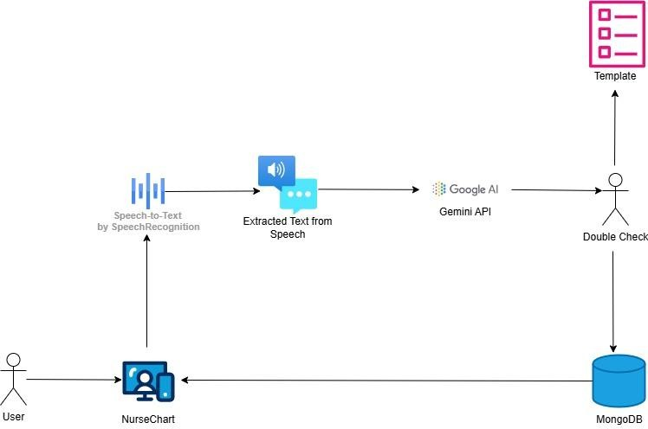
Figure 1. Methodology diagram

Flow Of NurseChart
The landing page will be the Login page, where it will ask for a username and password to verify the user's identity. I have applied Joi validation for the input fields. When the user presses the login button, it will call the backend to validate the user's credentials. If the credentials are correct, the user will be redirected to the Home page. Otherwise, the user will need to enter the correct credentials or register.

On the Home page, the database is called within the useEffect hook to retrieve all the templates. The user can download previous templates and start a new conversation by simply clicking the 'Start Recording' button. Once the conversation is over, the user can generate a report.

During the report generation process, the audio is converted to text using the Gemini model, after which the system asks for confirmation of the details before saving them to the database.

Finally, the user can clear the template and generate additional reports as needed in the same manner.
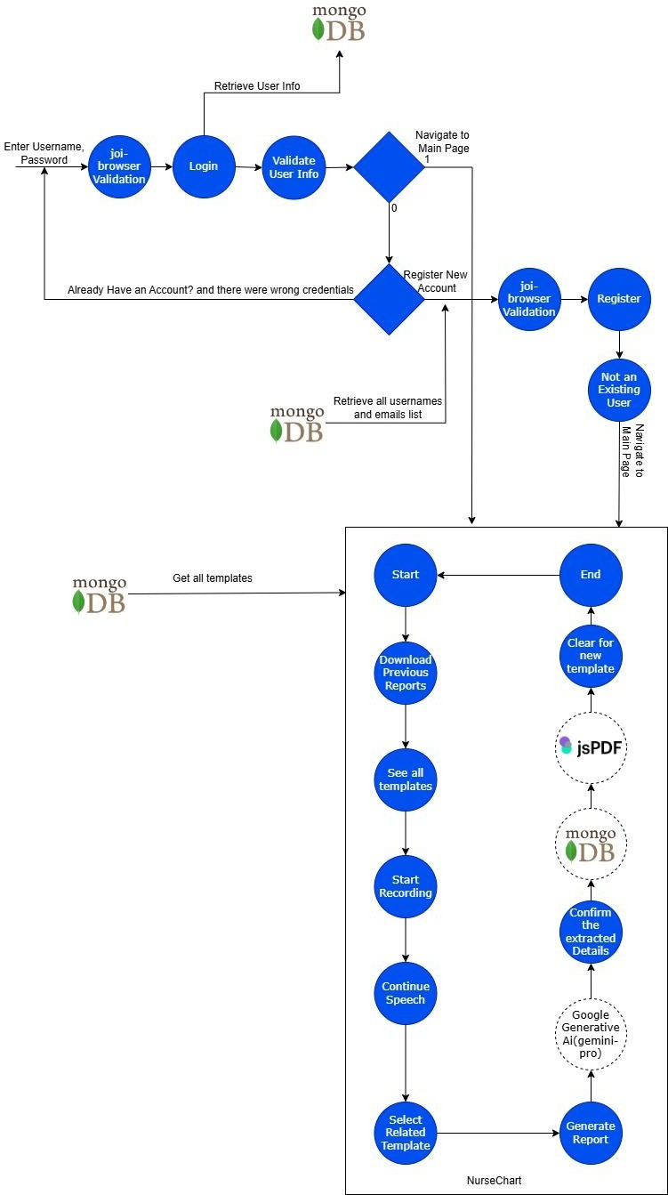
Figure 2. Flow Diagram of NurseChart

Development steps

Handling Start and Stop Recording
The handleStartRecording function begins recording, and the handleStopRecording function stops it. These functions ensure smooth operation when starting or stopping a recording.
// Function to start recording
const handleStartRecording = useCallback(() => { if (recognitionRef.current && !isRecording) {
recognitionRef.current.start(); setIsRecording(true);
}
}, [isRecording]);

// Function to stop recording
const handleStopRecording = useCallback(() => { if (recognitionRef.current && isRecording) {
recognitionRef.current.stop(); setIsRecording(false);
}
}, [isRecording]);

Voice To Text
This feature enables speech-to-text conversion using the Web Speech API. It initializes continuous speech recognition, capturing both interim and final transcripts. The system updates the displayed text in real-time and handles errors, ensuring accurate and responsive transcription. The implementation also includes proper cleanup when the component is no longer in use.
useEffect(() => {
const SpeechRecognition = window.SpeechRecognition || window.webkitSpeechRecognition;
if (SpeechRecognition) {
const recognition = new SpeechRecognition(); recognition.continuous = true;

recognition.interimResults = true; recognitionRef.current = recognition;

recognition.onresult = (event) => { let interimTranscript = '';
let finalTranscript = '';
for (let i = event.resultIndex; i < event.results.length; i++) { const transcript = event.results[i][0].transcript;
if (event.results[i].isFinal) { finalTranscript += transcript;
} else {
interimTranscript += transcript;
}
}

// Update the final transcript when the speech is finalized
setTranscription(prevTranscription => prevTranscription + finalTranscript);

// Update interim transcript separately if (textAreaRef.current) {
textAreaRef.current.value = transcription + interimTranscript;
}
};

recognition.onerror = (event) => {
console.error("Speech recognition error:", event.error);
};

// Cleanup on component unmount return () => {
if (recognitionRef.current) { recognitionRef.current.stop(); recognitionRef.current = null;
}
};
}
}, []);

Prompts for information extraction
Below are the prompts used for extracting specific information from text.

- Vital Signs Prompt: This prompt is designed to extract crucial medical details such as temperature, pulse, respiration, blood pressure, oxygen saturation, pain level, and blood sugar level, including their units in standard medical abbreviations.
- Head to Toe Assessment Prompt: This prompt focuses on extracting key observations related to various sections of a head-to-toe assessment, including general appearance, skin, head and neck, chest and lungs, heart, abdomen, extremities, GU system, GI system, and wounds and dressings. It aims to provide concise keywords or short phrases summarizing the main findings for each section.

// Prompt for extraction of Vital Signs const vitalSingsPrompt = `
Extract the following details from the text with their units in standard medical abbreviations:
- Temperature (e.g., °F, °C)
- Pulse (e.g., bpm)
- Respiration (e.g., breaths per minute)
- Blood pressure (e.g., mmHg)
- Oxygen saturation (e.g., %)
- Pain level (e.g., out of 10)
- Blood sugar level (e.g., mg/dL)

Text: ${transcription}
`;

// Prompt for extraction of Information for Head To Toe Assessment const headToToePrompt = `
Extract key details related to the following sections from the text. Focus on the main observations or findings:
- General Appearance
- Skin
- Head and Neck

- Chest and Lungs
- Heart
- Abdomen
- Extremities
- Genitourinary (GU) System
- Gastrointestinal (GI) System
- Wounds and Dressings

Text: ${transcription}

Provide concise keywords or short phrases summarizing the key findings for each section.
`;

Call to Google’s Generative Model
The process of calling Google’s Generative Model to generate content is based on given prompt.
const run = async () => { try {
const result = await model.generateContent(prompt); const response = await result.response;
const text = await response.text(); setIsLoading(false);
}
finally { setIsLoading(false)
}
}

Save template to database
This ensures that template data is safely stored and that users are informed of any issues during the operation.

// Save template to database axios.post('http://localhost:3850/api/templates', {
userid: userid,
templateid: newTemplateName, template: updatedTranscription,
}).catch(error => {
if (error.response) {
if (error.response.status === 500) {
console.error('Server error:', error.response.data.message); alert('Internal server error');
} else {
console.error('Unhandled error:', error.response.data.message); alert('An unexpected error occurred');
}
} else if (error.request) {
// No response received from server console.error('No response from server'); alert('No response from server');
} else {
// Request setup or other client-side error console.error('Error setting up request:', error.message); alert('Error in request setup');
}
});

Populating Modal’s response to document
This function ensures that modal responses are neatly formatted and saved as PDF files for documentation or sharing purposes.
// generate pdf
const generatePdf = (heading, body, fileName) => { const doc = new jsPDF({
orientation: 'portrait', unit: 'mm',
format: 'a4',
});

const margin = 15;
// Set the font size to 11 and add the heading doc.setFontSize(22);
doc.text(heading, margin, 25);

doc.setFontSize(11); doc.setTextColor(50);

const splitText = doc.splitTextToSize(cleanUpResponse(body), 180);

// Add the content with line wrapping
doc.text(splitText, margin, 35, { maxWidth: 180, align: 'left' });

doc.save(`${fileName}.pdf`);
}

Pre-load the templates list
This ensures that the previous template list from the database is available and up-to-date for the user’s needs.
useEffect(() => {
// Load templates if (userid) {
axios.post('http://localhost:3850/api/getAllTemplates', { userid
})
.then(response => {
const templates = response.data;

// Function to get all template IDs const getTemplateIds = (templates) => {
return templates
.filter(template => template.templateid)
.map(template => template.templateid);
};

// Get the list of template IDs

const templateIds = getTemplateIds(templates); setRecentTemplates(templateIds); setTemplatesWithIds(templates);
})
.catch(error => {
if (error.response) {
if (error.response.status === 500) { console.error( error.response.data.message); alert('Internal server error');
} else { console.error(error.response.data.message); alert('An unexpected error occurred');
}
} else if (error.request) {
// No response received from server console.error('No response from server'); alert('No response from server');
} else {
// Request setup or other client-side error console.error('Error setting up request:', error.message); alert('Error in request setup');
}
});
}
}, [userid]);

Technology Used

Frontend
The frontend of the application is developed using the following technologies:

- HTML: The standard markup language used for creating web pages.
- Tailwind CSS: A utility-first CSS framework for styling the application.
- React: A JavaScript library for building user interfaces, particularly single-page applications.
- Axios: A promise-based HTTP client used for making API requests.
- jsPDF: A library used to generate PDF files directly in the browser.

Backend
The backend of the application is built with:

- Node.js: A JavaScript runtime used for executing server-side code.
- MongoDB: A NoSQL database used for storing application data.

Third Party Integration
The project integrates with the following third-party service:

- Google Generative AI: Used for advanced AI-driven features and functionalities within the application.

Tools Used

GitHub
I have utilized GitHub to manage and organize my codebase efficiently, keeping all project files in well-structured directories. This helped me maintain a clean workflow as I progressed through the development phases.
- Assets folder: This folder contains all the project resources, including the prototype design, workflow diagram, and all information related to the templates extracted from nurse and patient conversations.
- Backend folder: This folder holds the code for the database and APIs, developed using Node.js.
- Frontend folder: This folder includes the React application for the project.

Here is the repo link for the complete code: NurseChart - GitHub Link

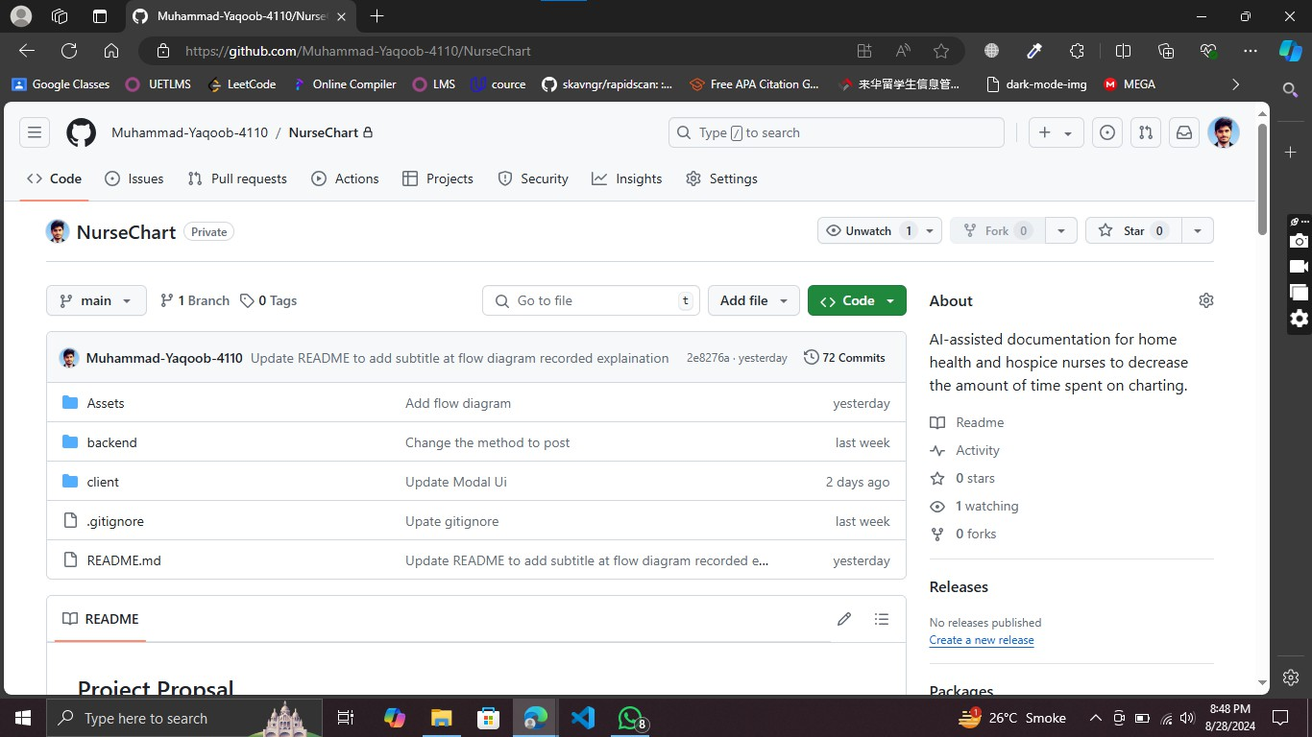
Figure 3. Tools Used GitHub

Run NurseChart locally

Prerequisites
- Node.js (version 14 or later)
- npm (Node Package Manager)

Clone the Repository
First, clone the repository to your local machine:
git clone https://github.com/Muhammad-Yaqoob-4110/NurseChart.git cd NurseChart

Run the Client Side

Front-end for NurseChart is implemented in React. This section provides instructions on how to set up and run the application.

Install Dependencies

Go to the project's client directory and install the dependencies
cd client npm install

Configuration
Create a configuration file named config.js in the NurseChart/client/src/components

directory with the following content:
const config = {
apiKey: "PASTE_YOUR_GEMINI_API_KEY_HERE"
};

export default config;

You can get your free Google Gemini Api key by following this: Get your Google Gemini Api Key

Running the Application

To start the React development server, run:
npm run start

The application will be available at http://localhost:3000 in your web browser.

Run the backend side

Install Dependencies

Navigate to the backend directory and install the required dependencies:
cd backend npm install

Configuration

You need to create a configuration file to set up the MongoDB URL and JWT verification token. This file should be placed in the NurseChart/backend/utils directory.

Create a file named config.json in the NurseChart/backend/utils directory with the following content:
{
"mongodb_url": "PASTE_YOUR_MONGO_URL", "jwt_verify_token": "adsfasdfjkh$#asdfasdf.adsfxc"
}

Running the Application

To start the backend server with nodemon, use the following command:
nodemon start

The server will be available at http://localhost:3850

Conclusion
In conclusion, this project successfully integrates multiple technologies to create a comprehensive solution for managing nurse-patient interactions and generating detailed reports. The frontend, built using React, Tailwind CSS, and supported by tools like Axios and jsPDF, provides a user-friendly interface that allows healthcare professionals to easily navigate through various functionalities. The backend, developed with Node.js and MongoDB, ensures robust data management and seamless interaction with the database, facilitating the storage and retrieval of crucial information.

The project also incorporates advanced AI capabilities through Google Generative AI, enabling the automated transcription of conversations and assisting in generating accurate reports. The Assets folder contains essential resources, including the prototype design and workflow diagram, which guided the development process. It also includes the extracted templates from nurse-patient conversations, which serve as a foundational component of the application.

Overall, this project demonstrates a strong alignment between technology and healthcare needs, offering an efficient tool for documentation and report generation in a medical context. The system's architecture is designed to be scalable and adaptable, allowing for future enhancements and integrations as required by evolving healthcare practices. This project not only meets the initial objectives but also lays the groundwork for potential expansion, making it a valuable asset for healthcare professionals.

